ECON236 Preliminary Review Questions (West F’21)

What is globalization? What are the 3 waves of globalization? What are the pros and cons of globalization? What is economic openness and how is it measured.
Globalization is basically a term that is used to describe of all the interdependence of the world wide cultures, populations as well as economies which are basically achieved by cross border trade in services and goods, flows of investment, information people and technology.
Waves of globalization
Globalists
Skeptics
Transformation lists

Pros of globalization
- Free trade is expected to help in reducing barriers for instance subsidies, tariffs, and VAT (value added tax) across the nations. Based on this, it is not a reality since we still experience a lot barriers encountered by free trade.
- According to the proponents, they argue that globalization do present free trade which later helps to promote global economic growth. For instance, will enable companies to be more competitive, job creation as well as lowering the price of the consumers.
- Competition that is evidenced between the states is basically meant to drive down the prices. Based on this idea on most cases the idea does not work since much of the countries manipulate their own currencies just to achieve price advantage.
- Globalization will provide poor states with infusion of foreign technology as well as capital thus presented with a chance to develop economically.
- Globalization and democracy goes hand in hand. This outlines that we should have business with the absence of colonialist designs.
- In a gradual move there is a creation of world power instead of sectors of compartmentalized power.
Cons of globalization
- Increased competition
- Disproportionate growth
- Environmental concerns

Economic openness
It is simply a degree in which nondomestic transactions important or reports do take place as they affects the size or growth in a national economy.
The economy openness is measured by the actual size of registered important as well as exports within a national economy

- What is meant by trade liberalization? Trade protectionism? What are the benefits of free trade including static and dynamic gains from trade? What are the arguments in favor of protectionism?
Trade liberalization means to remove or reduce barriers or restrictions on the free exchange of goods between nations. For instance barriers include tariffs like surcharges or duties and non-tariff barriers like quotas or licensing rules.
Trade protectionism refers as government policies that mainly restrict international trade that help domestic industries.
Benefits of free trade
- Theories of comparative advantage
- When the tariff barriers are reduced it leads to trade creation
- There is an increase on exports
- Economies of scale
- Competition is increased
- Trade becomes the main engine of growth
- Tariffs can as well do encouragement of inefficiency

Arguments in favor of protectionism
Safeguard domestic employment is to reduce important penetration. In terms of the identity AD=C +I + G + (X - M) it lowers M, to greater the aggregate demand or higher it level of employment or domestic output.

- Using constant slope production possibilities curves, be able to calculate the absolute and comparative advantage in the two-country case. Show the range of reciprocal terms of trade and the static gains from trade for both countries.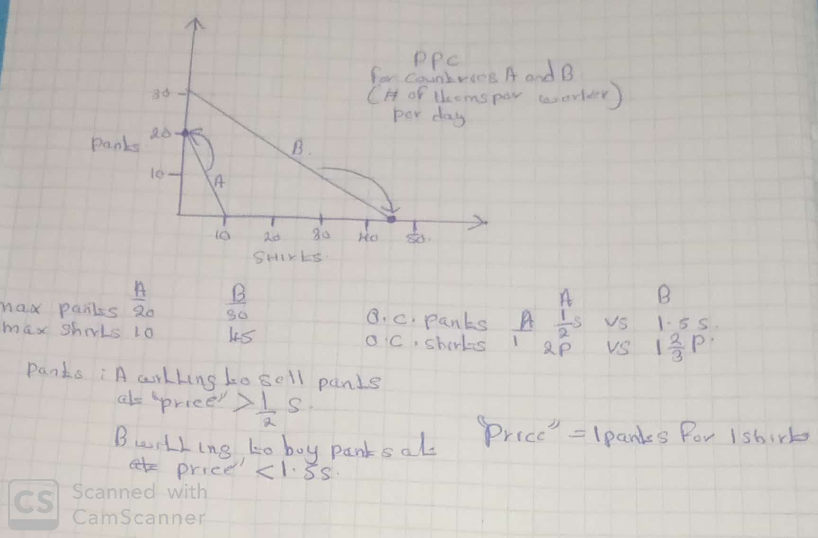

- What is meant by the ‘dynamic gain’ from trade? Cite and explain several of the dynamic gains.

Dynamic gains from trade it has benefits that accelerate economic growth to participating countries. It makes principle countries that optimum that uses available resources so national output is greater also raises it level of social welfare in the country.
It was from the post-world war II which has been characterized to be unprecendnt growth concerning economy as well as the progressive reduction concerning barriers associated with international trade as well as investment

- Draw and explain the logic and details of the globalization ‘whack-a-mole’ example I developed in class.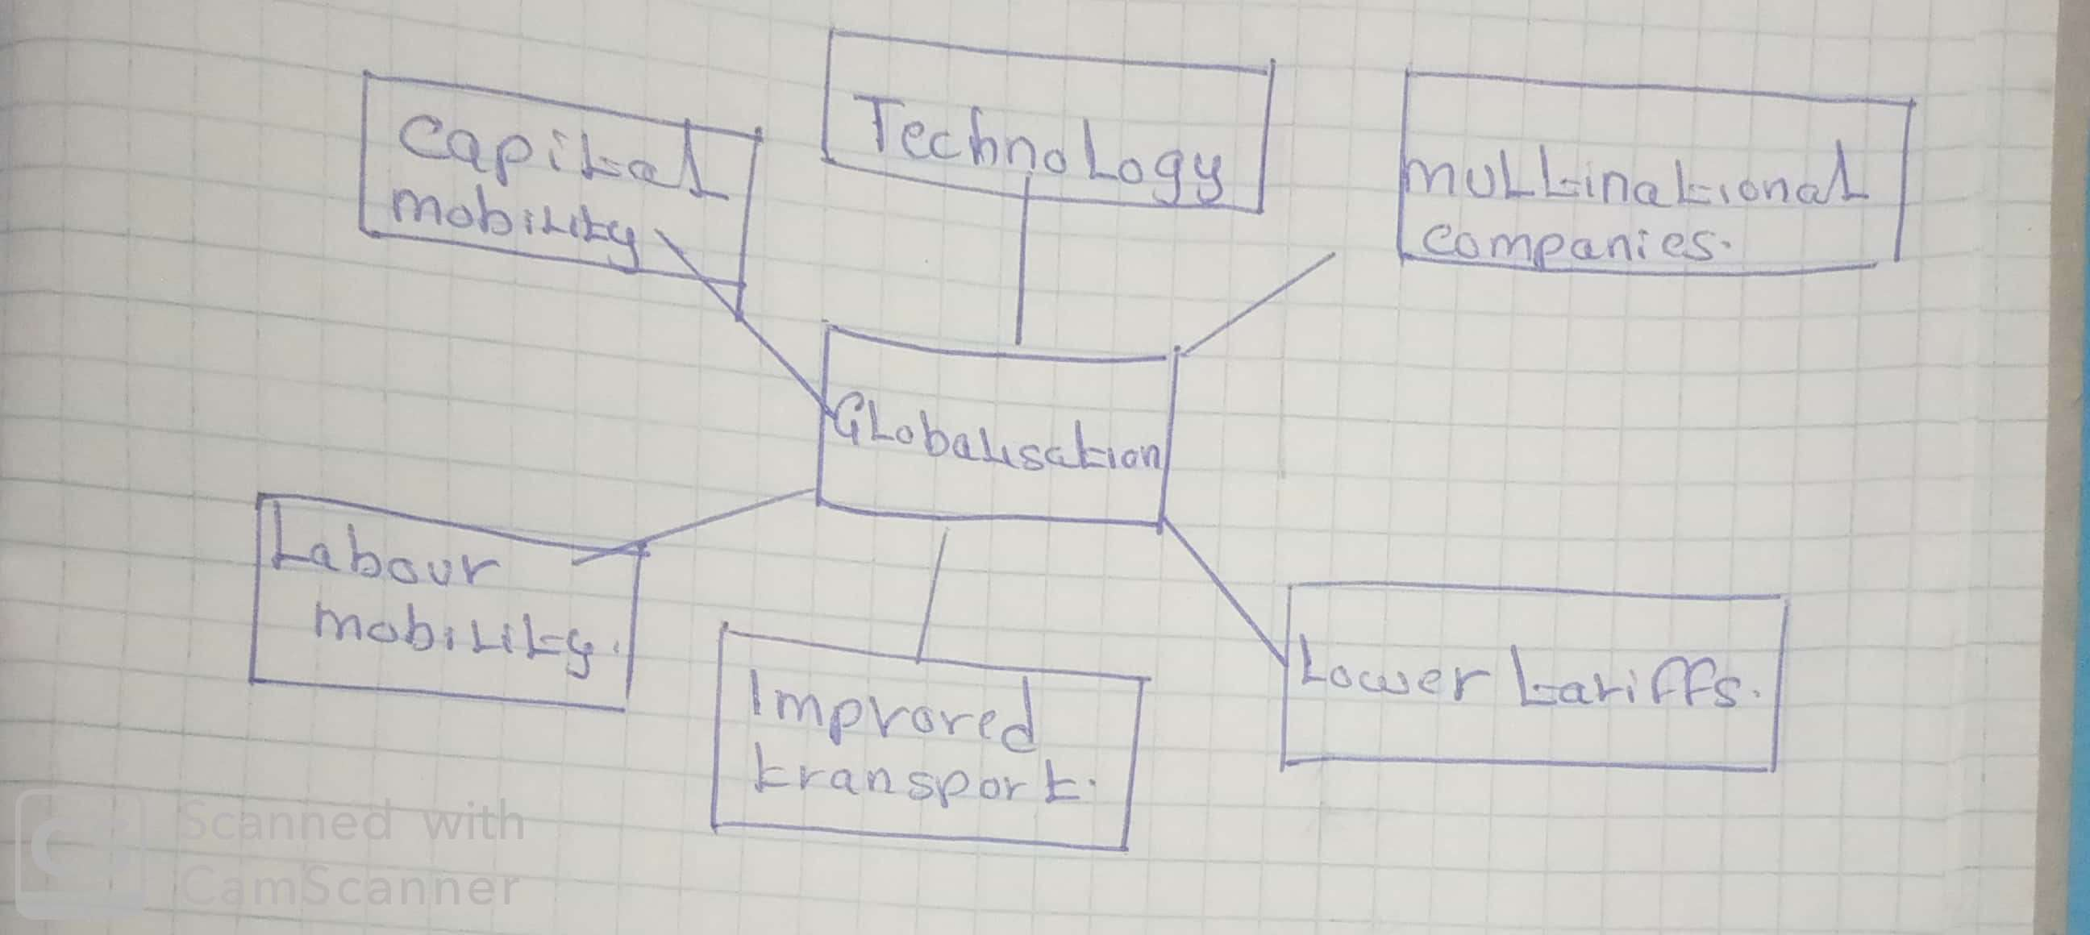
Explanations:
Improved technology. Improvement in technology has made it easier to communicate and share information all-round the word.
Improved transport. Improvement in means of transport for example movement by air has made it easier for people to move and transport goods all over the word.
Increased mobility of labor. People are more willing to move between different countries in search for work others for greener pasture
Improved mobility of capital. Due to reduction in capital barriers, it has become easy for capital to flow between different economies and this has increased the ability for firms to receive finance and also increased the global interconnectedness of global financial markets.

Reduced tariff barriers: Through the support of the WTO tariff barriers has been reduced and this has encouraged global trade
Expansion of companies: companies have grown and opened new branches in different parts of the word.

- What are the names and functions of the major supranational institutions who trace their beginnings to the Bretton Woods meetings in 1944? Which one took until 1995 to ‘get off the ground’ and why.

The Bretton woods institutions, the international monetary fund and the World Bank the three institutions were created to bring about orderly development of the world economy in the post war II era.
The World Bank get off the ground till today because of its powerful forces in the world economy.

- Explain the contributions to economic theory advanced by the classical economists, Adam Smith, David Ricardo, and John Stuart Mill.
A) Adam Smith Contribution

1. He made a clear cut recognition that probabilities could not be calculated using precise, single number answers since probabilities were indeterminate and imprecise.
2. Smith recognized that a real-world decision-making was very uncertain as opposed to being based on the mathematical concepts based on probabilities.
3. He recognized that as long as the probabilities were greater than zero, retaliatory tariffs may lead a country that had imposed a tariff on another country to rescind the decision.
4. Smith recognized that the main threat to economic prosperity originated from projectors, prodigals, and risk-takers who were able to get loans to leverage their debts.
(B) David Ricardo
1. The comparative advantage theory of trade explains international trade as the result of the relative difference in productivity rather than absolute difference.
2. He developed the theory of rent in his analysis of the returns to agricultural land when the land differs in location or fertility.
3. He developed the theory of wages and profits based on population theory where market-price of labor would always tend toward the minimum required for subsistence.

(C) John Stuart Mill
1. He developed the Principle of Political Economy which became the leading economics textbook for forty years after it was written.
2. He helped develop the ideas of economies of scale, opportunity cost and comparative advantage in trade.

- What was the contribution of Hecksher–Ohlin? Explain Factor Endowment Theory and how it not only impacts comparative advantage but income distribution. What was the Leontieff Paradox? What lessons are gained from this?

The main contribution of Hecksher ohlin is he gives a good explanation mathematically how a country should operate and do trade when resources are imbalanced throughout the world and make a profit.
Factor endowment theory states that countries are likely to be abundant in different types of resources which gives the country a comparative advantage in the good that uses the factor which it is heavily endowed hence increasing their income distribution.
Leontief paradox in the field of economics is that country with a higher capital per worker has a lower capital or labor in exports than in imports.
Lesson gained is that U.S should adapt its competitive policy to match its economic realities with other countries.

- List and explain some of the contributions to ‘new trade theory’, e.g. economies of scale, intra industry trade, life cycle, overlapping demand. What is meant by ‘dynamic comparative advantage’ and ‘industrial policy, outsourcing/offshoring, restoring?’
Some of the contributions to ‘new trade theory’.
Economy of scale. This means realizing much production at the lowest cost possible.
Intra industry trade. This means buying and selling products from the same industry e.g. importing and exporting the products of the same industry.
Overlapping demand. This a theory which suggest that international trade in manufactured goods is more successful between countries with same or nearly similar per capita.
Product Life cycle. This suggest that once a product has been adopted in the worlds market the production of the production becomes universals. The inventor of the product also imports the import.
Meaning of terms in relation to free trade
Dynamic comparative advantage: this is an economy's ability to produce a particular commodity or service at a lower opportunity cost than its trading competitors.
Industrial policy. This refers to any intervention or government policy that is put in to improve the business environment or change the economic structure in order to realize a good economic growth and societal welfare
Outsourcing/offshoring: this is where one firm/company hires another company to be responsible its trading activity and sometimes involves transferring employees and assets from one firm to another the other.

- What are the impacts of regulation (e.g. environmental, human rights)? Why are environmental regulations (e.g. The Paris Agreement) controversial in trade? How do transportation costs impact trade and what innovations have been impacting the movement of goods and services around the world?
Regulation can have negative or positive effects on the growth of market. To start with the positive effects one is regulation helps the business to use faster economies of scale hence maintaining technical standards. Secondly regulation strengthens competition mostly when it tackles information asymmetries. Regulation also protects consumers by making sure they have quality commodities and with fair prices. On the other hand poorly designed regulations cause harm than good one is they causes wastage of limited resources ,limit job creation , stifle innovation and business growth, undermine sustainable development and erodes the public’s confidence in our government.

Environmental regulations like the Paris agreement have reshaped national economies and value chains for companies across the globe hence seizing opportunities within the changing landscape to innovate and compete.
Transport costs have key impacts on the economic activities together with international trade the raising transport costs by 10 percent has reduces trade volumes by more than 20 percent hence leading to loss. The construction of railroads is the most significant innovation in transportation which enhances movements of goods and services.
- Free Trade is often described as a win-win situation. How is that true? Are there ‘losers’ with trade? How does trade impact wages and income disparity?
Free trade is not a win-win situation. There are winners and sellers. Some of the impacts of free trade on wages and income include it increases wage inequality, there is increase in profit relative to labor income as the rich tend own the bigger percentage of shares and free trade brings about redistribution of income within the economy. This comes about as some traders suffer losses and others realize.

